Düsseldorpheus, 1585
Johann Wilhelm, the Duke of Jülich, Kleve and Berg married at Düsseldorf on 16 June 1585 the countess Markgräfin Jacobe von Baden. The celebration was epic. Well, mythological at least.
On the third day of the event, a huge artificial mountain with two peaks was constructed. Upon each peak a musician representing the mythological musicians Amphion and Orpheus sat, playing. Amphion had applied his musical gifts to the building of the legendary walls of Thebes, charming the walls into place with his music and never lifting a hand. (Ovid Met. 6.146-312; 'most postclassical treatments of [Amphion] in the arts celebrate the power of Amphion's music.' Reid.) Orpheus' representative at the Renaissance hochzeit played on the false hilltop among a throng of wild animals assembled for the show.
A woodcut published two years later in Cologne shows the scene.
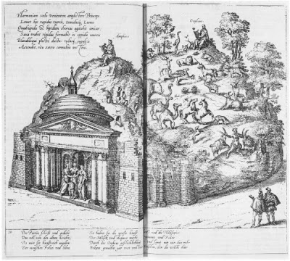
The allegorical purpose of the scene had something to do with invoking the muses, "in the form of Orpheus and Amphion," as sponsors for the newlyweds. Guests were told by placards posted around the scene how the mythological allusions had anything to do with the wedding. I well might have needed some help in the explication, too!
Orpheus gets top billing in lots of weddings, especially after 1600, when the wedding of Maria de' Medici and Henry IV of France witnessed the premier of Peri's Euridice — a watershed event in the history of opera that joined the forces of Caccini and Rinuccini at Florence's Palazzo Pitti and that is still being talked about. Throughout the 17th Century, Orpheus charmed the nethergods into relinquishing Eurydice in no fewer than 30 operas premiered from Vienna to Wolfenbüttel and from London to Madrid.
And further, Vienna and Graz had witnessed a similar mise en scene in 1571, when an artificial hill was erected — apparently like a parade float, in today's conception, pulled by four white drafthorses — and upon this mobile hilltop sat Eurydice and Orpheus along with representations of the inhabitants of the Underworld who were charmed by Ovid's Orpheus (i.e. Ixion and Tityos, and Tantalus, etc.).
So, particularly in light of that precedent, it is especially remarkable to me that Orpheus is there at the Düsseldorf wedding at the dawn before the 17th Century singing an entirely different tune.
Near contemporaries include Edmund Spenser, whose Faerie Queen (1596) includes Orpheus' music calming strife among the Argonauts (FQ 4.2.1), likely a role similar to that conceived in the company of Amphion at Düsseldorf.
The mythological pastiche is nicely explicated and brilliantly contextualized by E.-B. Krems, "Das Drama des Sehens und der Musik: zur Darstellung des Orpheus-Mythos in bildender Kunst und Oper der frühen Neuzeit," Marburger Jahrbuch für Kunstwissenschaft 36 (2009) 269 - 300. I owe all my knowledge of the Düsseldorf Orpheus/Amphion to her article, pp. 269 - 71.
OGCMA0785NOTOrpheus_Düsseldorf

