Nicolas Poussin, “Triumph of Neptune and Amphitrite”, mid-1630s, oil on canvas (part of ‘Bacchanals’ series for Château de Richelieu?), Philadelphia Museum of Art, accession no. E1932-1-1 The George W. Elkins Collection, 1932. — Amphitrite1.0029_Poussin

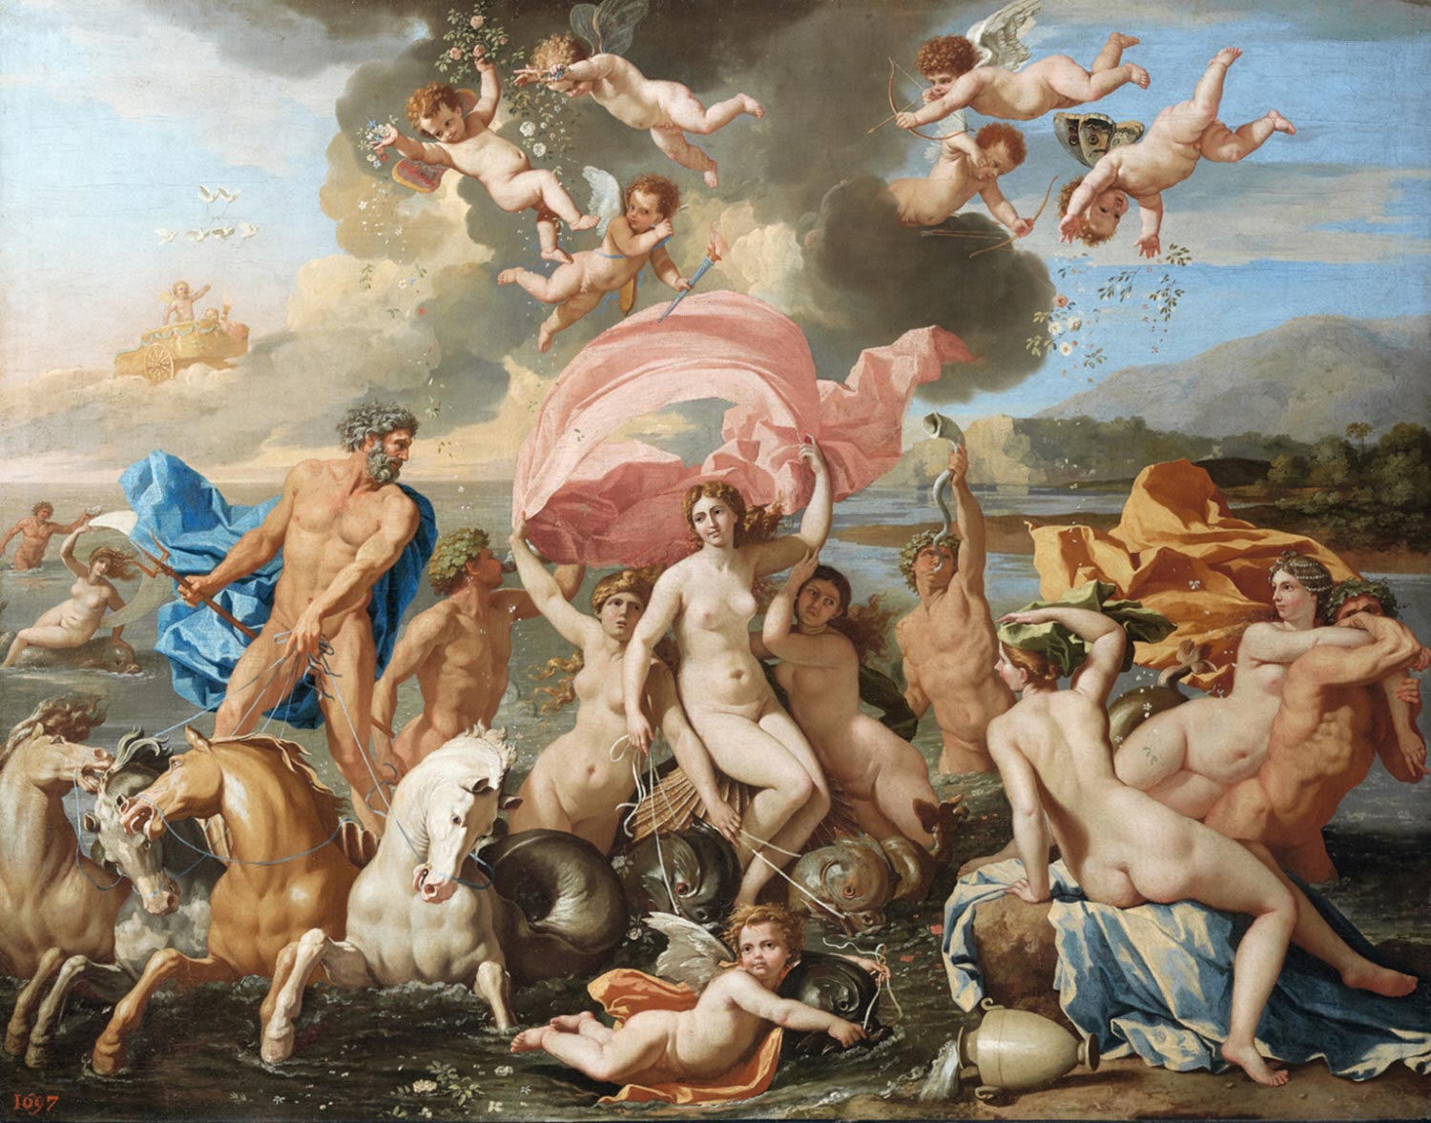
A super-hi-res of this painting is available at Google Arts & Culture:
https://artsandculture.google.com/asset/the-birth-of-venus/kwEtyhSaKD0s7g

Poussin left the canvas untitled. Consequently, scholars have debated the mythological subject matter. The Philadelphia Museum of Art titles it “The Birth of Venus”; however, in the label (click) the Museum states that “others see the sea god Neptune’s marine procession”, which would likely make that central figure Amphitrite, Neptune’s divine consort. Another option floated by the Museum is that Galatea is in the center.

The OGCMA sides with the interpretation that this is Amphitrite and indexes the picture as Amphitrite1.0029_Poussin, entitling it “Triumph of Neptune and Amphitrite” [= Poseidon1.0067_Poussin]. Many others agree.

OGCMA lists for Poussin under “Aphrodite, Birth of” two items — a) a set of three drawings archived at the Galleria Corsini, Rome, at the Musée Condé, Chantilly, and at the Stockholm Natinoalmuseum [AphroditeBirth1.0046_Poussin]; and b) a drawing entitled “Venus Landing on Cythera” at the Musée Bonnat, Bayonne [AphroditeBirth1.0047_Poussin]. If the present painting depicts Aphrodite’s birth, then it should likely be listed at AphroditeBirth2.0046_Poussin.

For the reading that this is Galatea’s Triumph, one should compare it to four Poussin items listed in OGCMA s.v. “Galatea”, but especially “The Triumph of Galatea” for which two drawings are extant in the Stockholm Nationalmuseum (Galatea2.0050_Poussin).

Because the Philadelphia Museum’s web-based label does not offer bibliographic support, deeper study of this intriguing dispute should go through the bibliographic sources offered by Reid in OGCMA ad loc. These are
Wright, Christopher. 1985. Poussin Paintings: a catalog raisonné. London: Harlequin. — no. 80, pl. 35
Blunt, Anthony. 1966. The Paintings of Nicolas Poussin: critical catalog. London: Phaidon. — no. 167
Thuillier, Jacques. 1974. L’opera complete di Poussin. Classici dell’arte. Milan: Rizzoli. — no. 93

- RTM

