Paul Manship, 1885-1966
“Time and the Fates” — OGCMAFates1.0106_Manship
1938
monumental plaster sundial
now destroyed (bronze copies survive)
Minn. Museum of Art; SAAM
for New York World’s Fair of 1939-1940

https://artsandculture.google.com/asset/worlds-fair-models/4gFy23s-lw5Bfw

Note:
GA&C treats the photograph as the artwork.
Margaret Bourke-White, 1938, “World’s Fair Models”,
b&w photograph, TimeLife_Image_813296

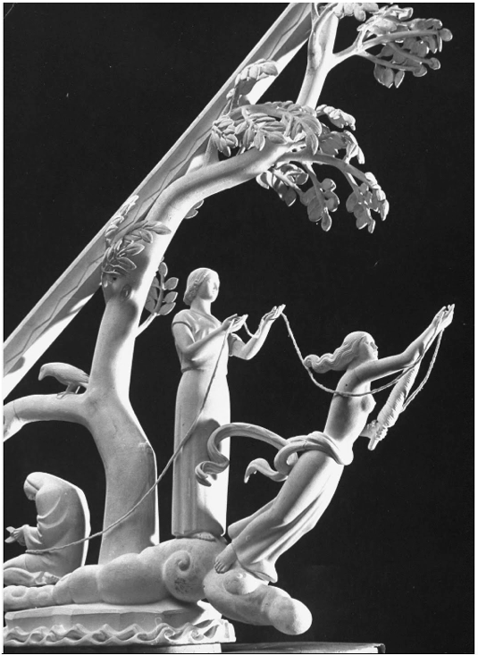
Narrative Gain — The three Fates — Clotho (the Spinner), Lachesis (the Apportioner), and Atropos (the Inflexible, or the Un-turning One) — are presented in classical form. (cf. OGCMA s.v. “Fates”) Manship builds them into a sundial so as to mark the passage of diurnal time. Thus, the Fates play their roles every single day (as long as the sundial stands). Fate here is not big-time Destiny, but something normal. Considerably more mundane than typical application of the Fates, this one reminds the viewer to consider destiny on a daily basis.

— RTM

