John Hoppner, 1758-1810, “Portrait of Emily St Clare as Bacchante”, 1806-1807
Nelson-Atkins Museum of Art, 45-1
nelson-atkins.org/collections

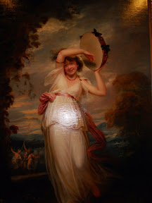

http://books0977.tumblr.com/post/146567470547/portrait-of-emily-st-clare-as-a-bacchante

