Spoiler alert: If you have never seen and want to enjoy the last few minutes of Hitchcock’s Psycho, don’t read this paper.

Hitchcock’s mastery of mise-en-scene is much discussed at all levels of film studies. Psycho offers a study of the auteur at work. Hitchock’s use of classical allusions within the film is not unnoticed. However, the visual citation of Orpheus in a key moment of suspense has been overlooked. Mythological shorthand offers the viewer a critical clue to solve the Bates mystery.
Lila Crane enters the Bates home (scene 218) while Sam Loomis occupies Norman Bates in increasingly suspenseful conversation in the motel office. Suspense builds as Lila approaches, then enters the home. The camera’s point of view switches repeatedly from Lila’s to the home’s, looking into Lila’s search face. AS with Argobast’s approach, the home’s POC is markedly superior to the intruder’s. Lila proceeds ominously up the stairway where we saw Arbogast fail. Lila ascends into space we know was vacated the night before, when Norman argued with Mother and removed her unwilling from her bedroom.
Mrs. Bates’ bedroom is the one place, to this point in the film, where the camera has tempted our gaze but forbidden penetration. So, as Lila opens the door to enter the bedroom (fr. 874), the Herrmann score placidly accompanies her safe entry into a deeply mysterious space. Finally the camera comes to Lila’s eye-level. Arbogast’s arrival at this landing and Norman’s were viewed from the dizzy height of superior POV. The subsequent scene rewards repeated viewing, because of Hitchcock’s thematically charged presentation of visual evidence.
Hitchcock allows us to follow Lila across the threshold, filling the right half of the frame. We see the room through her eyes. As she steps forward toward the room’s center the camera reverses. Our POV perceives no apparent alarm on her face. (fr. 876) A cut alters the perspective slightly and the frame’s left half of the frame is filled with a bronze sculpture that is shown twice; not in its entirety at first. (fr. 878 Its shadow cast onto the wall by an unseen overhead light completes some detail of the sculpture’s unshown portions. After several quick cuts showing Lila’s investigation of the room, Hitchcock returns that same sculpture, entirely fully visible because Lila is fully in the room. (fr. 882)
Raoul-Charles Verlet’s sculpture entitled “La Doleur d’Orphée” is hardly famous. Though it won the 1887 Prix du Salon and took runner-up honors in the same year’s Prix du Rome, the work has not made a significant mark in the history of French sculpture. The original was destroyed in 1942 when other statuary in the Place Malesherbes was melted down by the Nazi occupants. The award winning original is now preserved in archival images and in small-scale bronze castings produced by the Parisian firm Barbedienne. Auction records indicate variant titles which apparently all describe this one work by Verlet.
The lover who descended to the underworld to recover his prematurely departed bride, Orpheus secured in classical Roman mythology the role of the world’s most remarkable lover. His musical prowess was so deft that he could charm the gods who rule there to release Eurydice back to his care. The famous failure notwithstanding, the Orphic accomplishment qualified him as the one living artist who had crossed to the other side and back. Other mythological heroes may have returned from the world of the dead, but Orpheus alone had done it for love.
Full details of that bronze on the threshold of Mrs. Bates’ room are difficult to discern. But, the figure is recognizable, even in an instant, as Orpheus. The ministrel strides forward across a skulking Cerberus, whose triple growling heads face toward Orpheus’ rear. Behind Orpheus’ left foot, his tortise-shell lyre has fallen to the ground. His desperate hands are expressively empty. He lifts these plaintively to the upper air and wrenches his head in abject bereavement. A sash veils Orpheus’ genitals, enhancing his modesty in the Barbedienne reductions. It billows behind him, suggesting the very instant of Eurydice’s evaporation.
This image of Orpheus bestrides the entry to Mrs. Bates’ bedroom thematically. The mythological allusion acts as a clue for the audience’s comprehension of Norman’s activities in the past decade and his relationship with his mother. Orpheus at the room’s entrance alludes to Norman’s situation multivalently. Marriage imagery comes into play whenever Orpheus’ rescue of his bride is considered, and Lila will momentarily contemplate the deep impression left in Mrs. Bates’ bed. Orpheus’ successful negotiation over the threshold of death plays in Norman’s story as well, for he will seem to have transgressed this same boundary. The overwhelming saddness of Orpheus’ abject failure underpins all final assessments of his heroic undertaking. So also, the psychotic trainwreck of Norman Bates’ life also stemmed initially from an unnatural attempt to hold onto a departed loved one.
Conventionally, Orpheus’s mythical refusal to accept loss … [positive & negative]… all this with the allusion to Orpheus wrought by the placement of Verlet’s bronze.
Several other objects within Psycho play this same game with the viewer. Hitchcock cites mythological art throughout. For “a film has got to be ocularly interesting and above all it is the picture which is the thing,” said Hitchcock in 1936. The placement of Mieris’ Suzanne et les Viellards on the back wall of the motel office, indeed over the very peep hole through which Norman watches Marion undress, is perhaps the most famous such moment in the film. Classically minded viewers with sharp eyes may catch the glimpse of Titian’s Venus at her Toilette with Two Cupids which Marion herself mirrors during her telling snack in the parlor with Norman. Right through to the moment that Norman struggles to free himself from capture in the fruitcellar, writhing like Laocoön, Hitchcock proves himself the master of classical mythological imagery. Especially telling is the placement of the Eros at the base of the staircase in the Bates home, its arrows pointing menacingly at both Arbogast and Lila as their desire for truth presses them forward into realms of perversely skewed eros.
The director's narrative gain through the placement of this sculpture plays both to Norman's psychological trainwreck — i.e. his attempts to cheat death by keeping mother alive unnaturally — and to Lila's transgression of death's threshold in her search for Marion. Any living person who transgresses the threshold of Mrs. Bates’ room treads the Orphic path into the world of the dead. It's a rich allusion, a clue to the perceptive viewer regarding the discoveries of the next few minutes and unlocks the mysteries of Norman’s actions. Hitchcock later discussed the importance of offering visual clues to the audience: “I’m a great believer in making sure that if people see the film a second time they don’t feel cheated. That is a must. You must be honest about it and not merely keep things away from an audience. I’d call that cheating.”

Hitchcock’s application of the Orpheus myth in Psycho perpetuates its more overt application in Vertigo where he adapts a novel with an overt Orpheus theme into a conquest over Cocteau’s towering Orphée.

on Lila in Mrs. Bates' room:
James Naremore, Filmguide to Psycho (Bloomington and London: Indiana UP, 1973), 67.
"Hitchcock has crammed Mrs. Bates' bedroom with Victoriana, even though the nineteenth-century trappings are distinctly anachronistic. ... Nearly all details Hitchcock shows us are designed to express Mrs. Bates' repressive character." [no mention of the Orpheus]

Amanda S. Wells, Psycho: director Alfred Hitchcock, Ultimate Film Guides (Longman, York Press, 2001), 74
"[Marion] is replaced by her virtual double, Lila, who is the one character who drives forward the search for Marion and then Arbogast and finally discovers the truth about Mrs. Bates."

"Recognizable themes in [Psycho, viz other mature films by Hitchcock] include the influence of the dead over the living, the transference of guilt, the punishment of sexual transgression and the influence of the mother figure. Recurring visual motifs that can be linked to other Hitchcock films include mirrors, birds and eyes, while voyeurism is both a visual motif and a structuring device within the film." 25-26

production designers for Psycho: Robert Clatworthy and Joseph Hurley, but to some extent also Saul Bass.

Stephen Rebello, Alfred Hitchcock and the Making of Psycho (Marion Boyars, 1998), 70 cites production designer Clatworthy recalling "Hitchcock's enjoining set decorator George Milo to make certain that the bathroom fixtures gleamed." Well p. 49

Rebello p. 69: costs for Mrs. Bates' bedroom $1250. Rebello p. 69
"Robert Clatworthy recalls Hitchcock's being far more finicky about odd, unsettling details of decor -- such as the kitschy sculpture of the hands folded in prayer in Mother's room -- than with the structures themselves.”
Art Direction (Black-and-White) nominee (The Apartment won) for 1960 Academy Award: Art Direction: Joseph Hurley, Robert Clatworthy; Set Decoration; George Milo.

Barbara Creed, The Monstrous Feminine: film, feminism, psychoanalysis (Routledge, 1993), 146 identifies Susanna and the Elders

also identified as Susanna and the Elders by Durgnat p. 118.

remarkable: when Arbogast enters the parlor, he sees only the birds. The paintings are scarcely seen, certainly shadowed over in his POV shots.
When Argobast enters the Bates home, he looks directly at the Cupid who is shooting him.

Joseph W. Smith III, The Psycho File: a comprehensive guide to Hitchcock's classic shocker (Jefferson NC and London: McFarland, 2009)123-24.
cites Naremore and Durgnat on the room
Bloch novel p. 144 is where the room is described.
Clatworthy and Hurley are credited with set design
"Everything in the room is seems geared to demonstrate that Norman's whole world is dead, frozen, trapped in the past."
portrait over the bed: Norman's maternal grandmother?
"It seems as though this stern-looking matron must have presided regularly over the bedroom trysts of Norman's parents [and step father?], including the act of love that gave him life."
embroidered needlework on the vanity noticed by Lila.
massive fireplace. photos there are the Bates. Cupid is between them.
"Below this we can see the fireplace grate, unlit, with no wood, merely ashes-- recalling what Norman told Marion much earlier: If he left his mother alone, 'her fire would go out.'" p. 124
citing Rothman: "we feel closer to Norman's mother than at any other moment in the film." (Rothman 321)

mine:
double mirror: Lila and Mrs. Bates are similar.

Alexandre Astruc, "The birth of a new avant-garde: la camera-stylo" in P. Graham, ed., The New Wave: critical landmarks (Secker and Warburg, BFI 1968

an online version of the Psycho screenplay: www.paradiselost.org/psycho.html

Wells mentions these mirrors: "Mirrors are used throughout the mise-en-scene of Psycho to symbolise the duplicitous divisions of personality." Marion in ladies' room. Bates Motel mirror reflects Marion, Arbogast, then Saem and Lila. Mrs. Bates' room has the double mirror.

Raymond Durgnat, A Long Hard Look at 'Psycho', 2nd ed.Palgrave MacMillan 2010.
"Marion's dress closet was tiny, in a bare wall; Mrs. Bates' is a sumptuous armoire; its door, a scary mirror, generates two 'false Lilas'. Marion placed the stolen money on her bed; now a body is imprinted on the coverlet. The body-moulded bed-linen recalls Norman's obsession with linen-changing -- and Marion's body moulding the shroud. The cake of fresh soap evokes bodies in bathrooms. The fireplace, in cold, white marble (with, says the script, fresh ashes) picks up on Norman's phrase, 'The fire has gone out.' The boy-Cupid statues are 'mummies' of Norman's childhood. The folded hands echo Norman's hands folded beneath his candy-chewing mouth and, perhaps, Marion's soaping around her neck. We can almost smell the soap, the linen, the stone, the dry chill. All in all, this room is a total contrast to Lowery's un-airconditioned office." p. 231

studying the mise en scene leads to understanding how the film creates meaning for the spectator
Van Sant's attempt shows how the mise en scene creates meaning for the director

Paramount films: 1953-1959 -- Rear Window (1954), To Catch a Thief (1955), The Wrong Man, Vertigo, North by Northwest. They refused to back Psycho, so he financed the film himself. Universal does Birds, Marnie, Torn Curtain, Topaz, Frenzy, Family Plot.

politique des auteurs: a timeline:
post occupation flurry of interest in Hollywood films made during the war.
Francois Truffaut, Eric Rohmer, Claude Chabrol, Jean-Luc Goddard
Under leadership of Andre Bazin, these four wrote for Cahiers du Cinema
these critics created terminology of auteurism
1948 Alexandre Astruc in Cahiers du Cinema: film is becoming real art
1951 Astruc analyzed Under Capricorn for Cahiers
2nd issue of Cahiers Jean-Luc Godard pronounces in a review of Strangers on a Train that Hitchcock is one of the greatest directors of cinema.
1954 Cahiers dedicates entire issue to Hitchcock.
1957 Rohmer and Chabrol publish the first book on Hitchcock.

even if it is now controversial to look for the politique des auteurs in Vertigo, it seems to have been resonant with Hitchcock himself in the moment of Vertigo.

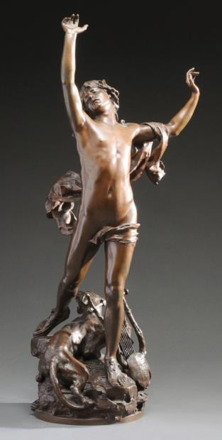
PSYCHO (A. Hitchcock, dir.; Paramount, 1960)

1:36:00 Marion’s sister Lila enters the Bates house
1:36:52 She enters Mrs. Bates’ bedroom
1:37:08-13 The sculpture is unnoticed on a pedastal beside her, then she strides into the room to examine Mrs. Bates’ bed.
Raoul Charles Verlet (1857 – 1923), “La Doleur d’Orphée” (1887; second grand prix de Rome and prix du Salon), large bronze sculpture with brown patina.
1:37:36 (below) Then, after Lila inspects Mrs. Bates’ closet, the sculpture appears fully visible. Lila is looking past the sculpture into the room.
http://www.hitchcockwiki.com/1000/47/0884.jpg, copyright Universal Studios (2014)

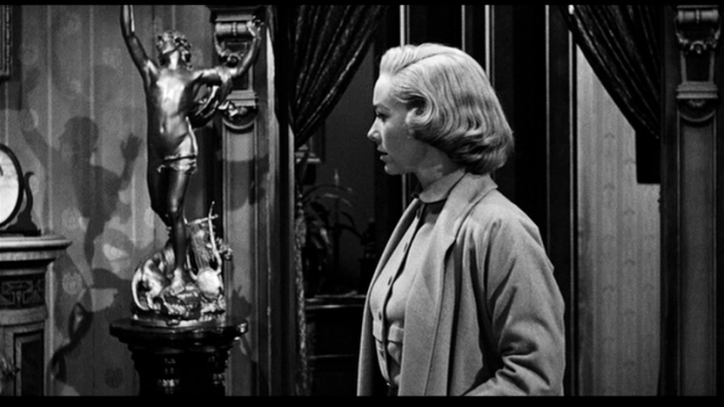

http://www.hitchcockwiki.com/1000/47/0884.jpg, copyright Universal Studios (2014)

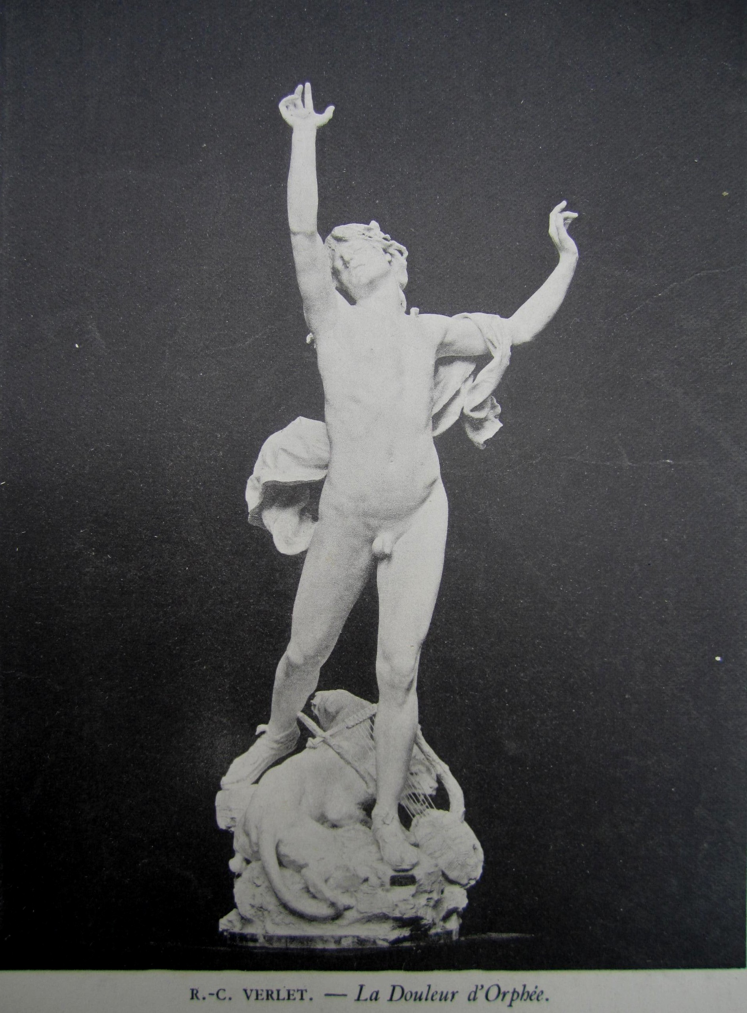
http://farm3.staticflickr.com/2776/4513518661_4c8838e18e_o.jpg

Klellberg, Pierre, Les bronzes du XIXe siècle, Les Editions de l'Amateur, Paris, 2005, p.675

http://www.artprecium.com/estimation-raoul-charles-verlet-1857-1923-la-douleur-dorphee-13378-50.php: “Le plâtre original de cette œuvre fut présenté au Salon de 1887 et connu un succès important, la grande sculpture fut installée Place Malesherbes à Paris (aujourd’hui place du Général-Catroux dans le XVIIe arrondissement) et fut détruite en 1942. Verlet remporta le second grand prix de Rome et le prix du Salon de 1887 pour cette Douleur d'Orphée. Par la suite, Barbedienne l'édita en quatre tailles différentes.” … “Raoul Verlet, est un artiste français né en1857 et décédé en 1923. Il pratique la sculpture très tôt, à l’adolescence. Après avoir travaillé pendant 2 ans à Bordeaux, il s’installe à Paris. Il y étudie, à l’Ecole des Beaux-Arts auprès de Cavalier et de Barrias. Sa sculpture remporte ensuite un succès important. En effet, il obtient une mention au Salon pour deux statues tombales, puis il est révélé au grand public grâce au monument aux enfants de Charente morts en 1870. Il réalise ensuite, sur commande de la commune de Châteauroux, une sculpture commémorant le sacrifice des enfants de l'Indre. Son œuvre intitulée La Douleur d’Orphée, lui vaut le second grand prix de Rome et le prix du Salon de 1887. En 1900, il obtient la Médaille d’Honneur au Salon. Il est ensuite nommé Chevalier de la Légion d’Honneur. En 1910, il est élu membre de l’Académie des Beaux-Arts.”

Oxford Art Online: Benezit Dictionary of Artists, s.v. Verlet, Charles Raoul (or Raoul Charles):
“Charles Raoul Verlet was a pupil of Pierre Jules Cavelier, Louis Ernest Barrias, François Jouffroy, Millet and Édouard May. He exhibited for the first time in Paris at the Salon in 1880 and won a second-place medal and the Prix du Salon in 1887, a gold medal in 1889 and a medal of honour and the Grand Prix in 1900. He was made a Chevalier of the Légion d'Honneur, and became an Officier of the Légion d'Honneur in 1900 and a member of the Institut de France in 1910.

Museum and Gallery Holdings
Angoulême: Coulombe, Lieutenant Colonel of the Engineers; Flute Player; Low Reliefs after the Parthenon Friezes
Châteauroux: Bust of a Child
Digne-les-Bains: Filial Devotion
Limoges: Statue of Adrien Dubouché
Paris (Louvre): Bust of Doctor Barthe; Lhermitte the Painter; Prodigal Daughter; Suffering of Orpheus
Rouen: Diana
Vannes: Monseigneur Sebaux, Bishop of Angoulême

Auction Records
London, 5 Nov 1980: Orpheus in Hell (bronze with brown-green patina, h. 33 ins/84 cm) GBP 2,900
London, 10 Nov 1983: Orpheus and Cerberus (patinated bronze, h. 33 ins/84 cm) GBP 750
Lokeren, 1 June 1985: Suffering of Orpheus (patinated bronze, h. 49¼ ins/125 cm) BEF 600,000
London, 6 Nov 1986: Orpheus and Cerberus (c. 1870, patinated bronze, h. 32½ ins/82.5 cm) GBP 2,000
” "VERLET, Charles Raoul." Benezit Dictionary of Artists. Oxford Art Online. Oxford University Press, accessed January 15, 2014, http://www.oxfordartonline.com/subscriber/article/benezit/B00190015

The only thing I’ve found was a student paper —Carla Segurola, CI5830 assignment from appstate.edu— that identified this not by name but thus: “Her extravagance is exemplified by a statue which casts a terrifying shadow on the wall (another split, resembling an earlier shot of Marion’s dying hand stretched out towards the shower curtain).”

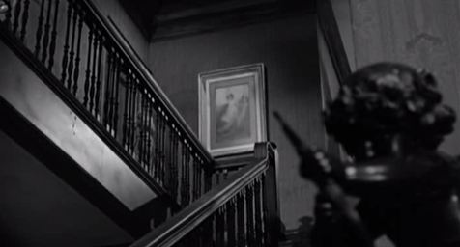
other mis en scene observed by Segurola: “Cupid, its arrow is pointed at us”

Psycho, directed by A Hitchcock (1960; Universal Paramount, 2008).
J. Stefano, A. Hitchcock, and R. Bloch, Psycho: screenplay, Prod. #9401 (S.I.: Paramount Pictures, n.d. [after Universal Pictures’ acquistion “in the 70s”]; individual leaves dates 11-10-59 thru 12-7-59). [Univ. S. Alabama copy]
Stills referred to by frame number, 1000 Frames of Psycho, Hitchcockwiki — http://www.hitchcockwiki.com/wiki/1000_Frames_of_Psycho_(1960)
T. Reiss’ research on the statues of Alexandre Dumas and others, in The Black Count: glory, revolution, betrayal, and the real count of Monte Cristo (New York: Crown, 2012), 328 - 29. The Place Malesherbes is now known as the Place du Général-Catroux in the XVIIth Arrondissement, where the Metro station preserves the placename associated with the victim of the Revolution.
Minimal history of the work’s creation and auction records is provided online at www.artprecium.com [accessed 15 Jan 2014]. See also Benezit Dictionary of Artists Oxford Art Online(Oxford University Press), s.v. “Verlet, Raoul-Charles” [accessed 15 Jan 2014], http://www.oxfordartonline.com/subscriber/article/benezit/B00190015
Attributing the allusion to Hitchcock per se, compresses all matters of auteurism as they pertain to Hitchcock’s filmmaking. Bloch’s novel (Simon & Schuster, 1959) manifests no overt reference to the Orpheus myth. Among its several intertextual references the only classical mythological reference is the barely remarkable mention made by Norman in dialogue with his Mother, when he alludes to their “Oedipus situation” and she dismantles him emotionally for “thinking that [he’d] like to kill [her.]” (Chapter ). The novel’s two visits to Mrs. Bates’ bedroom (by Norman in Chapter 5 and then by Lila in Chapter 15) offer no evidence that Bloch imagined the presence of Orpheus in the decor.
A. Hitchcock, “Close Your Eye and Visualize!” cited in Hitchcock on Hitchcock: selected writings and interviews, ed., S. Gottlieb (Berkeley: U California Press, 1995) 247.
Willem Van Mieris “Suzanne et les Viellards” (1731) (var. attributed to Frans Van Mieris the Elder) Perpignan, Musée Hyacinthe Rigaud (stolen 1972); cf. Musées Nationaux Récupération MNR 552. The picture appears in several shots during Marion’s snack in Norman’s parlor (e.g. 1000 Frames of Psycho, frame 331) and then in the moment before Norman peers through the peep hole at Marion’s shower preparation (frame 358).
In his famous trailer for the film, Hitchcock himself draws attention to the painting of Susannah, breaking off in aposiopesis: “This painting is very important, because —.”
J. Solomon, The Ancient World in Cinema (New Haven and London: Yale University Press, 2001), 22-24. Solomon shows that Marion’s positioning opposite the painting mirrors Titian’s Venus in key moments. Solomon notes further that in his hommage to Hitchcock (1998), Gus Van Sant’s placement of the same painting on another wall misses Hitchcock’s effect. [OGCMA0116Aphrodite_TitianHitchcock] IN POINT OF FACT: Solomon’s text is accurate, but his caption beneath Figg. 11/12 is erroneous. The frame shown and explicated does not appear in the theatrical version of the film. Janet Leigh does not touch her right arm with her left hand in the released scene, nor is she shown from the superior POV manifest in Solomon’s figure. The still frame shown bears a hand-written caption “5061-13”, which indicates ____________. I like the explication; and the text itself deals with Hitchcock’s placement of the Titian without such an error.
Frame 935. T. Cohen, Hitchcock’s Cryptonymies (Minneapolis: U Minnesota Press, 2005), 90. Norman’s pose strikes a recollection of Susannah, as well.
I disagree with David Thomson, The Moment of Psycho: how Alfred Hitchcock taught American to love murder (New York: Perseus 2009), 86, who blithely dismisses sets in Psycho’s second half for their “specious clues.” No details are offered.d
Interview with Ian Cameron and V.F. Perkins in Alfred Hitchcock: Interviews, ed. Sidney Gottlieb (Jackson: U Mississippi Press, 2003), 48.

