http://www.philamuseum.org/collections/biography/16581.html

Scherf, Guilhem. "Autour de Clodion: variations, répétitions, imitations." Revue de l'art, no. 91, (1991), pp. 47-59; [ordered via ILL, since HBLL online offers no images.]
Poulet, Anne L., and Guilhem Scherf. Clodion, 1738 - 1814. Paris: Réunion des Musées Nationaux, 1992. [ordered via ILL, since HBLL does not own this.]

Is the bronze below actually by Clodion? It is attributed to him on the internet.

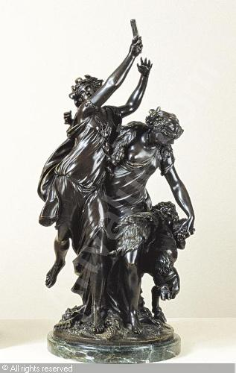

Alfred Hitchcock Presents
Season 1 Episode 5, “Into Thin Air”

Directed by Don Medford
Art Director is Martin Obzina
Set director is James S. Redd

Various stills from the episode are in folder “HitchcockPresentsThinAir”

Spoto’s Hitchcock: the dark side of genius
has listings of the contributors to various Hitchcock films, including the 17 episodes of Hitchcock Presents that he directed.

1960 season, episode called “Mrs. Bixby and the Colonel’s Coat” is done under art direction of Martin Obzina and Set Decorator James S. Redd.
it appears that others are done with Martin Obzina, but the combination seems unusual.
Indeed, the Mrs. Bixby piece and Thin Air have many of the same team.

