Pierre-Paul Prud’hon (1758-1823)
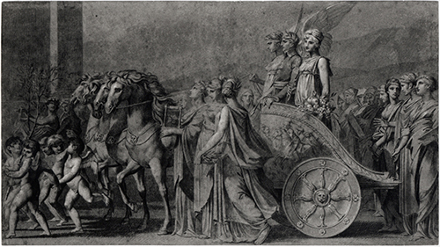
“The Triumph of Bonaparte” a.k.a. “Peace”— OGCMAMuses2.0146_Prud’hon
1801
Black chalk with stumping on blue laid paper
Art Institute of Chicago, Gift of Dorothy Braude Edinburg
to the Harry B. and Bessie K. Braude Memorial Collection, ref. no. 2012.90
sketch for painting in Chantilly, Musée Condé

Note:
The RMM author (Söffner) seems to know the painting in Chantilly.
I could find easily a digitized image of the painting, but
found the artist’s sketch at the Chicago Institute of Art on-line https://www.artic.edu/artworks/151457/the-triumph-of-bonaparte

Narrative Gain — “Early in the 19th cent., Neoclassicism in particular brought new form and function to the M[uses], revisiting ancient or early modern formulae and incorporating them in new contexts. … Pierre-Paul Prud’hon’s Triumph of Bonaparte, or Peace (1801, Chantilly, Musée Condé), where, as on the François Vase, the M[uses] are part of a triumphal procession around a chariot, except that in this case the chariot bears Napoleon as mousagetes [the Muses’ supervisor].” — citing Jan Söffner, s.v. “Muses,” in Brill’s New Pauly Supplements I- vol. 4: The Reception of Myth and Mythology, ed. by Maria Moog-Grünewald. Consulted on-line 6 Aug 2020 - http://dx.doi.org/10.1163/2214-8647_bnps4_e812670.

— RTM

