The Current Cinema
The Enchanting Archeological Romance of “La Chimera”
The ghosts of the past haunt Alice Rohrwacher’s fourth feature, which stars Josh O’Connor as a tomb raider nursing a broken heart.

By Justin Chang
The New Yorker, March 28, 2024 [accessed 30 August 2024]
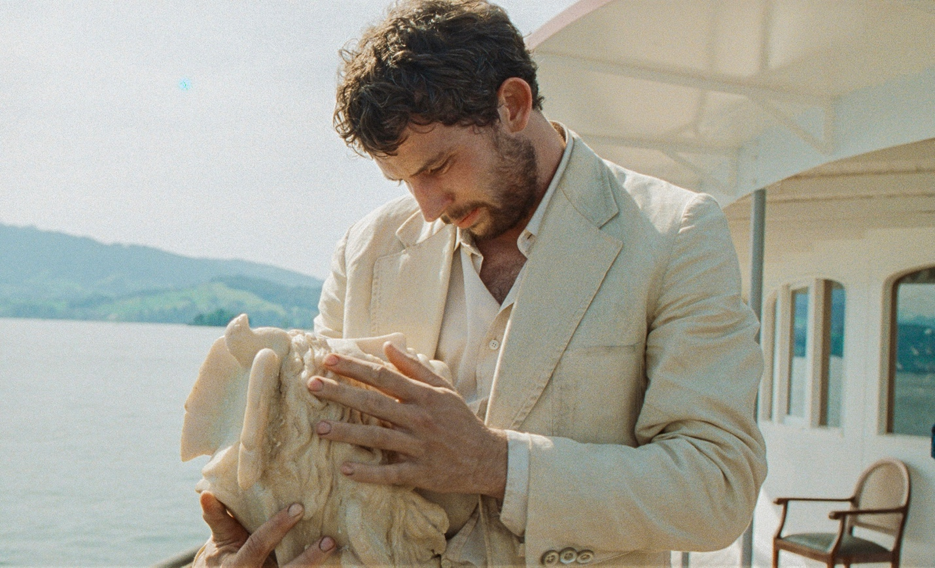
Josh O’Connor in “La Chimera.”Photograph courtesy Ad Vitam Distribution

The Italian writer and director Alice Rohrwacher may be the most quietly mischievous time traveller at work—or at play—in contemporary cinema. Her films, although typically set in or near the present day, are suffused with an almost primordial air of fairy-tale enchantment. You can seldom be sure exactly when the action is taking place, in part because Rohrwacher focusses on rural communities and traditions that exist at a defiant remove from the modern world: a coastal Catholic enclave in “Corpo Celeste” (2011), a family of Tuscan beekeepers in “The Wonders” (2014), a cluster of central-Italian sharecroppers in “Happy as Lazzaro” (2018). But more significant is her cinematic sleight of hand, which strands us between then and now. Even as she peers into the cracks and crevices of old Italy, the twitchy arcs of her storytelling and the restless, inquisitive motions of her camera throw off an unmistakable modernity of feeling.
“La Chimera,” Rohrwacher’s moody and marvellous fourth feature, is set in the nineteen-eighties, but it could be unfolding two decades earlier—or later. In any event, the title primes us for a tale of mythological resonance, and rightly so. The protagonist, Arthur (Josh O’Connor), is a twentieth-century Orpheus in a grubby linen suit who, when we meet him, is dreaming of his Eurydice: a beautiful woman named Beniamina (Yile Vianello), who calls to him, in ghostly visions, from across a seemingly unconquerable divide. How did he lose her? Did she leave him, or did she die? No answer is immediately forthcoming, and Arthur is soon jolted rudely awake; we see that he’s fallen asleep on a train, rattling its way toward a Tuscan town called Riparbella. A few young women grin and giggle in his direction, wondering who this handsome but bedraggled-looking traveller could be.
Rohrwacher’s movie abounds in mysteries, and her central sleuth is something of an enigma himself, not least because of the actor playing him. Until now, Rohrwacher has generally worked with nonprofessional Italian leads; an Emmy-winning English star represents something decidedly new under her Tuscan sun. But the casting works, magnificently. O’Connor may be best known for playing a young Prince Charles on “The Crown,” but he doesn’t exude even a hint of royalty here, and his command of the Italian language, while imperfect, has a fluency that suggests a deep love for and immersion in the culture. For all that, his Arthur remains a lowly outsider, with a downcast gaze, a peevish temper, and a deep well of melancholy that never feels one-note. You keep scanning his reactions for clues about his past, and savoring the warm little smiles that occasionally break, like beams of sunshine, across his face.
Arthur has just been released from prison, after a sentence of unspecified length, for grave robbing—a crime that is also his longtime vocation, and one that, for seeming lack of better options, he intends to resume. In Riparbella, he reluctantly reunites with his old gang of tombaroli, or tomb raiders, who are eager to once again make use of his talents. Arthur possesses what one of his friends calls “the gift of finding lost things.” By using a dowsing rod and, crucially, paying close attention to the strange, not always pleasant signals in his body, he always knows exactly where they should dig. Into the earth the shovels go, and out spring various Etruscan artifacts, mostly pottery, that were entombed, roughly two millennia ago, alongside their deceased owners.
These relics will fetch modest sums on the black market, but Arthur appears neither concerned about the spoils nor, until much later in the movie, in any way troubled by what he and his fellow-tombaroli are doing: ransacking and exploiting history for profit. Arthur is too lost in his mournful reveries, his futile longing for Beniamina, to care much about the consequences. But Rohrwacher, pointedly, does care. In “Happy as Lazzaro,” she explored the incursions of predatory capitalism—or, to put it more simply, human greed—into the lives of ruthlessly exploited tobacco farmers; now, in “La Chimera,” she suggests the moral costs of disturbing the dead. For some of us who first saw the movie at last year’s Cannes Film Festival, mere days after having watched the latest “Indiana Jones” romp, it was instructive—and moving—to lose ourselves in Rohrwacher’s vastly richer archeological adventure. She digs deep, and what she excavates are more questions than answers.
In one extraordinarily beautiful sequence, Arthur and his pals venture into an underground treasure trove full of priceless Etruscan artifacts—including a gorgeous milk-white statue—that haven’t been disturbed for centuries. As the first rays of moonlight spill across the cavern, the paintings on the walls seem to dull in detail and intensity; the colors drain, and the lines fade. In a single moment, Rohrwacher gets at something haunted and true. We like to tell ourselves that the appreciation of art is something that makes us human, but some art is distorted beyond recognition—and even destroyed—by the very gaze that might lend it meaning.
It hardly seems a coincidence that the one character who angrily denounces the tombaroli is named Italia, as if she alone were speaking out against the plundering of her country’s legacy. (Never mind that she is played, in a delightfully unexplained twist, by the Brazilian performer Carol Duarte.) Italia is an odd duck, both the story’s voice of conscience and a source of comic relief, a figure of fun and possibility. She’s an aspiring singer, but she’s hopelessly tone-deaf; she has a job doing domestic chores, but she does them terribly. She also becomes a foil and a potential love interest for Arthur. If anyone can drag him out of his emotional ruins, it’s her.
Italia works in the dim, cavernous Tuscan villa of an older woman named Flora, who is the mother of Arthur’s elusive Beniamina. When Arthur walks back into Flora’s life, she greets him with unconcealed joy. “My dear friend, my only friend,” she coos, hoping against hope that her beloved daughter may not be too far behind. Really, though, the most important thing to know about Flora is that she is played by Isabella Rossellini, who, with a wondrous mix of warmth and imperiousness, confers on this movie an almost subliminal blessing. Her presence helps us accept O’Connor’s all the more readily; clearly, there is room for more than one well-known face in this carefully deglamorized world. Rossellini is also, of course, another link to the past; her mere presence summons old and memorable cinematic ghosts.
Previously, I had never thought of Rossellini’s father, the pioneering neorealist filmmaker Roberto Rossellini, as a significant influence on Rohrwacher, but the ground-level naturalism of the latter’s style makes the association, in this instance, hard to ignore. But Rossellini isn’t the only late Italian master Rohrwacher effortlessly evokes. “La Chimera” boasts a rich, earthy tactility that’s reminiscent of the work of Pier Paolo Pasolini; it also features a scene of impromptu village festivities, the kind of vibrant human parade that often spills forth from a Federico Fellini epic. Elsewhere, Rohrwacher and her brilliant director of photography, Hélène Louvart, conjure a world of cinematic antiquities through a panoply of sly visual tricks (rounded frame corners, square-shaped aspect ratios, comically sped-up action sequences) and by shooting on a mix of film stocks: 35-mm., 16-mm., and Super 16.
Such old-style trickery is, so to speak, nothing new; for some self-regarding auteurs, twiddling with aspect ratios has become a formalist signature. But Rohrwacher is after something deeper than a mere flaunting of cinephile technique, or a showy display of nostalgia. At the heart of “La Chimera” is the question of how we bear the weight of the past while living in the present, and the answer that Rohrwacher settles on strikes me as both sensible and hopeful: we must, to the best that we can, eradicate any meaningful difference between the two. That’s why her filmmaking bridges eras with such a seamless matter-of-factness, and why she enriches her cinematic language with timeless storytelling traditions; at various points throughout, a troubadour sings of Arthur and his exploits (“All he longed for was a fuller life / His heart nourished by a richer source”), enshrining this modern hero in his own future legend.
Arthur, for his part, may be too heartbroken by the past to make peace with it; he can only surrender to it. And surrender he does, slipping once more beneath the surface of the earth and stumbling right into one of the most sublime endings I’ve seen in recent memory. But his is not the only way. One of the final scenes in “La Chimera” takes place not underground but at the Riparbella train station—a moldering, abandoned public space that we’ve already seen in a state of disrepair. But now we find that Italia has transformed it, with magpie-like pluck and resourcefulness, into a temporary home for herself and her young children. It’s a lovely revelation, and it tells us something about the kind of person Italia is, and perhaps the kind of artist Rohrwacher is: where most of us might see forgotten ruins, they behold the possibility of something new. ♦

