PersephoneSearch2.0001_Messina

Messina, Piero (director). 2015. L’Attesa. Motion picture. Released on DVD, in French and Italian with English subtitles by Oscilloscope Laboratories, cat. no. OSC-069.

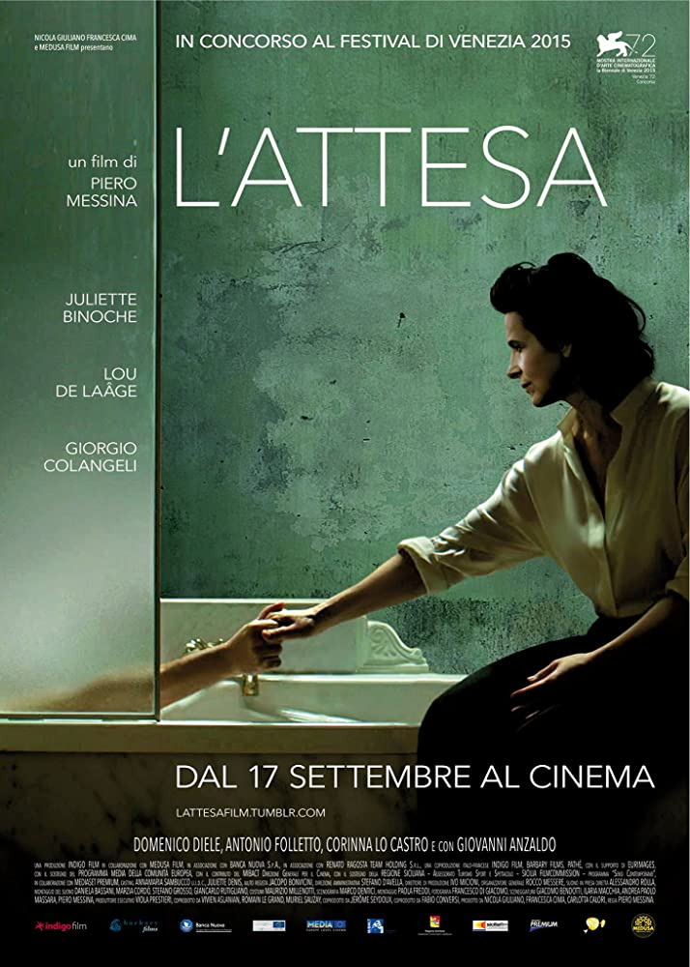
— Image from imdb.com.

A grieving mother (Binoche) receives at her Sicilian villa her deceased son’s girlfriend (de Laáge). Drama gradually builds as the visitor slowly realizes the mother’s emotional struggle.
Set in the culturally timeless landscape near Enna — where the ancient cult of Proserpina long ago developed into a unique annual Easter celebration — this beautiful film stands as a compelling reception of the myth of Ceres’ search for her daughter. It can inform the reading of classical texts from the Homeric Hymn to Demeter to Claudian’s De raptu Proserpinae.
See http://ogcma.byu.edu/PersephoneSearch1.0000_Reid.htm

