Pygmalion2.0191_Cukor

Cukor, George (director). 1964. My Fair Lady. Motion picture. Released on DVD 1998 by Warner Home Video.

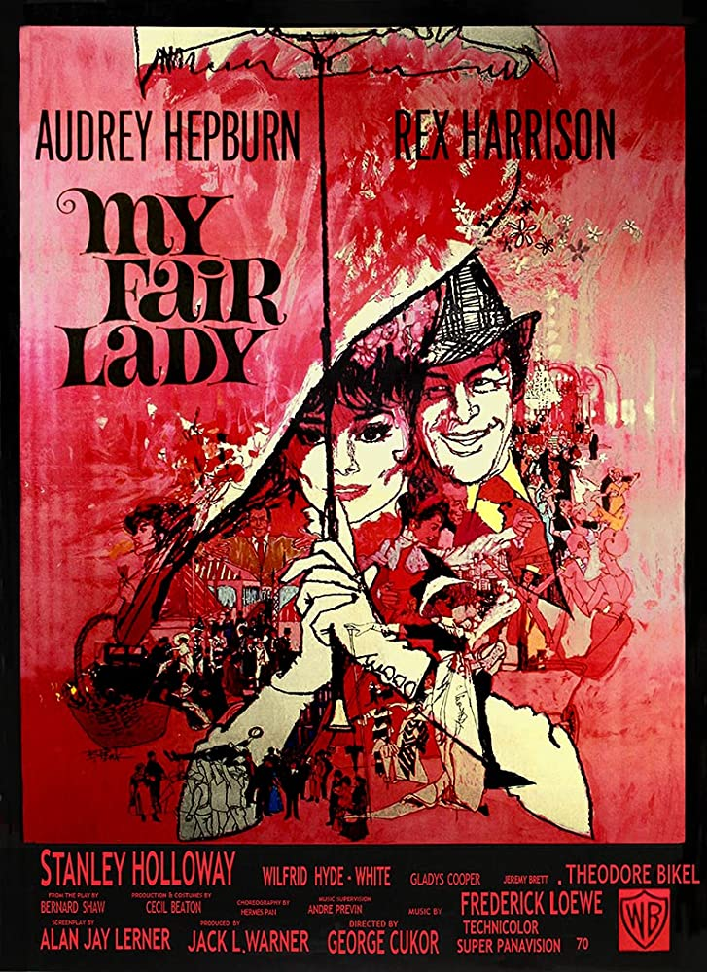
- Original poster from imdb.com

Linguistics professor Henry Higgins (Harrison) sets out to manufacture a glorious woman from a “deliciously low” street urchin named Eliza Dolittle (Hepburn). In fact, she nearly reinvents him.
Cukor’s lush motion picture adapts the Broadway musical by Frederick Loewe and Alan J. Lerner, which was in turn an adaptation of George Bernard Shaw’s stage-play Pygmalion. Although Cukor’s adaptation bears no overt acknowledgement of the source myth, academic questions about the nature of adaptation are fairly asked here. But the film is so engaging that those questions can very well go unasked. (See http://mythmatters.blogspot.com/2012/08/my-fair-lady-and-pygmalion-its-pretty.html and http://mythmatters.blogspot.com/2014/09/why-i-will-probably-find-time-for.html)

See http://ogcma.byu.edu/Pygmalion1.0000_Reid.htm

